Epsom & Ewell F.C.
13
v
Chipstead
Tuesday, 6th December 2016 – 7.45 p.m.
Good evening! We are in the unusual situation of hosting our landlords Chipstead today and hope they know the way to the away dressing rooms!

We were due to meet in a friendly earlier this season, but this was put back due to the early start to the Combined Counties League. As a result, when we were drawn together in the Surrey Senior Cup it made sense to double this match up as a Dave Wilson Trophy match. With all due respect to the Surrey F.A. I shall concentrate on our much missed long-serving Secretary here.

For those newer supporters, Dave Wilson was a valuable member of this club from the time he joined us in 1971 to the point he was taken from us in September 2006 at the tragically early age of 56. Dave carried out many varied posts, but his official one was as Secretary, which he started with the Reserve Team from 1973/83 and then for all teams for a further 23 years.

Despite the absence of a ground for so long, one of the greatest achievements of this club in recent years has been the creation and continuation of the Dave Wilson Trophy which tonight commemorates its tenth event. In recent years has been restricted to a single match and this is the third against our landlords. With the score at 1-1 this is arguably the decider, with the additional carrot of progress to the Third Round of the Surrey Senior Cup (last 16). Please note that this match would go straight to penalties should the scores be level after 90 minutes. It’s good to see the Surrey F.A. copying the Dave Wilson Trophy format after all these years!

We were last here ten days ago when we worked really hard to create a 2-0 lead against a dogged AFC Hayes team, only to concede twice towards the end and settle for a 2-2 draw. We then travelled to Worcester Park on Saturday for a League Cup tie, where we ran riot winning 6-3 in a match where we might have had ten on another day. As it was Daryl Cooper-Smith scored four times and Agi Panayiotou got the other two as we eased into the Quarter-Finals.

We face a test on Saturday as we visit Hartley Wintney for a League match. If we are good enough to compete for the title, then someone needs to take points off them and this week it is our turn! Following that encounter we have three consecutive home matches against Hanworth Villa on Tuesday 13th December, Chertsey Town on Saturday 17th and Raynes Park Vale on Tuesday 27th December. This last match will kick off at 11.30 a.m. so please mark that in your diaries.

We are still in urgent need of both match and player sponsors, so if you can help, or know someone at a local business who might be interested, please have a word with a Committee Member for details. Thank you!

Enjoy the game!

Rich

You can follow us on Facebook: www.facebook.com/epsomandewellfc Twitter: @EEFCOfficial and
Instagram at: www.instagram.com/epsomandewellfc We also have a Youtube channel now!

Cover photos by Gemma Jarman

- Agi Panayiotou strikes our 2nd goal against AFC Hayes on Saturday 26th November

- A picture of Dave Wilson from 1989 celebrating his 40th birthday

Cherry Red Records Combined Counties League
Premier Division Table 2016/17
incl Saturday 3rd December | P | W | D | L | F | A | Pts | GD | H | A
Hartley Wintney | 23 | 19 | 2 | 2 | 76 | 22 | 59 | +54 | 18/3 | 10/12
Westfield | 21 | 14 | 5 | 2 | 49 | 20 | 47 | +29 | 18/2 | 1-2
Hanworth Villa | 22 | 12 | 3 | 7 | 36 | 28 | 39 | +8 | 13/12 | 14/1
Walton & Hersham | 18 | 11 | 5 | 2 | 30 | 15 | 38 | +13 | 4/3 | 1-1
Knaphill | 21 | 11 | 2 | 8 | 46 | 40 | 35 | +6 | 4-0 | 8/4
Guildford City | 24 | 10 | 5 | 9 | 52 | 49 | 35 | +3 | 17/1 | 2-0
Epsom & Ewell | 19 | 10 | 4 | 5 | 48 | 27 | 34 | +21 | X | X
Horley Town | 19 | 10 | 4 | 5 | 42 | 28 | 34 | +14 | 3-0 | 17/4
Colliers Wood United | 22 | 9 | 5 | 8 | 39 | 37 | 32 | +2 | 14/4 | 0-5
Windsor | 24 | 9 | 5 | 10 | 40 | 41 | 32 | -1 | 2-0 | 1-2
Bedfont Sports | 18 | 9 | 3 | 6 | 37 | 37 | 30 | 0 | 5-1 | 7/2
Camberley Town | 20 | 8 | 4 | 8 | 37 | 26 | 28 | +11 | 0-0 | 1/4
Spelthorne Sports | 21 | 7 | 5 | 9 | 33 | 34 | 26 | -1 | 7/1 | 25/2
CB Hounslow United | 18 | 8 | 2 | 8 | 33 | 37 | 26 | -4 | 1-5 | 12/11
North Greenford United | 20 | 7 | 4 | 9 | 42 | 43 | 25 | -1 | 22/4 | 1-2
Abbey Rangers | 20 | 7 | 4 | 9 | 29 | 37 | 25 | -8 | 7-1 | 20/2
Farnham Town | 19 | 7 | 2 | 10 | 31 | 41 | 23 | -10 | 25/3 | 2-1
AFC Hayes | 21 | 5 | 5 | 11 | 31 | 42 | 20 | -11 | 2-2 | 28/1
Sutton Common Rovers | 18 | 5 | 3 | 10 | 22 | 35 | 18 | -13 | 2-1 | 2/1
Raynes Park Vale | 23 | 4 | 5 | 14 | 30 | 50 | 17 | -20 | 27/12 | 1-1
Chertsey Town | 20 | 4 | 5 | 11 | 23 | 52 | 17 | -29 | 17/12 | 11/2
Badshot Lea | 22 | 4 | 2 | 16 | 28 | 62 | 14 | -34 | 4/2 | 4-1
Bedfont & Feltham | 21 | 3 | 4 | 14 | 26 | 60 | 13 | -34 | 21/1 | 9-2

Lucky Day? – 6th December
Played 13 - Won 5 Drawn 3 Lost 5 - For 19 Against 18 - PPG 1.38 - Average
Our Club record against Chipstead
Played 6 - Won 2 Drawn 0 Lost 4 - For 9 Against 14 - PPG 1.00 - Poor
Our Largest wins and losses against our opponent
29th October 2013 - W 4-2 - Southern Combination Cup 2 (H)
15th August 2006 - L 3-6 - Combined Counties League (A)
Their Last Visit
Tuesday 29th October 2013 - W 4-2 - Southern Combination Cup 2

First Eleven Appearances 2016/17 - (max 26)
Name | Debut | 2016/17 |  |  |  | Career Totals
 |  | App | Sub | Total | Goals | App | Sub | Total | Goals
CLARK-GLEAVE Charlie | 23/08/2016 | 1 | 2 | 3 | 0 | 1 | 2 | 3 | 0
COOPER-SMITH Daryl | 03/01/2015 | 20 | 1 | 21 | 24 | 50 | 9 | 59 | 44
DEAN Dan | 02/08/2014 | 17 | 2 | 19 | 0 | 85 | 6 | 91 | 2
DEWAR Ali | 29/10/2011 | 0 | 1 | 1 | 0 | 55 | 36 | 91 | 10
EACOTT Michael | 02/08/2014 | 20 | 0 | 20 | 0 | 105 | 1 | 106 | 0
FARRELL Matt | 02/08/2014 | 24 | 0 | 24 | 11 | 110 | 4 | 114 | 29
FERDINANDO Matt | 20/09/2014 | 13 | 3 | 16 | 2 | 66 | 9 | 75 | 16
GALLAGHER Jordan | 07/08/2016 | 12 | 12 | 24 | 6 | 12 | 12 | 24 | 6
GRIFFIN Reisse | 08/08/2015 | 20 | 4 | 24 | 2 | 48 | 10 | 58 | 4
HASTINGS Craig | 08/08/2015 | 17 | 5 | 22 | 1 | 54 | 9 | 63 | 1
HEAGNEY Adam | 16/08/2016 | 15 | 3 | 18 | 0 | 15 | 3 | 18 | 0
HENDRY Rob | 08/08/2015 | 16 | 7 | 23 | 3 | 46 | 18 | 64 | 15
MCKAY Alex | 20/12/2008 | 16 | 3 | 19 | 3 | 124 | 33 | 157 | 11
NEALE Tom* | 13/10/2015 | 6 | 5 | 11 | 7 | 22 | 24 | 46 | 17
NORTH Rhys* | 16/08/2015 | 2 | 2 | 4 | 0 | 19 | 9 | 28 | 1
NWACHUKWU Jason | 01/10/2016 | 4 | 5 | 9 | 0 | 4 | 5 | 9 | 0
PANAYIOTOU Savvas | 03/01/2015 | 20 | 3 | 23 | 3 | 52 | 11 | 63 | 10
PRICE Matt* | 23/08/2016 | 2 | 0 | 2 | 1 | 2 | 0 | 2 | 1
ROBINSON Sam* | 22/10/2011 | 7 | 1 | 8 | 1 | 61 | 6 | 67 | 14
ROSE Daniel | 25/10/2016 | 2 | 2 | 4 | 0 | 2 | 2 | 4 | 0
SALEH Mennar* | 24/09/2016 | 0 | 2 | 2 | 0 | 0 | 2 | 2 | 0
SMITH Matt | 08/08/2009 | 0 | 2 | 2 | 1 | 91 | 45 | 136 | 11
TANTON Matt | 02/08/2014 | 22 | 1 | 23 | 1 | 79 | 5 | 84 | 3
TAYLOR James | 26/08/2013 | 20 | 3 | 23 | 1 | 106 | 15 | 121 | 7
THOMPSON Elliott | 09/02/2016 | 3 | 0 | 3 | 1 | 7 | 9 | 16 | 1
TURPIE Alistair | 31/03/2016 | 6 | 1 | 7 | 0 | 8 | 1 | 9 | 0
WATRET Jack* | 02/08/2016 | 1 | 0 | 1 | 0 | 1 | 0 | 1 | 0
* player has left the club

Latest Results and Fixtures
Combined Counties League – Saturday 26th November
CB Hounslow United | 1-5 | Westfield
Chertsey Town | 2-2 | Bedfont Sports
Epsom & Ewell | 2-2 | AFC Hayes
Farnham Town | 1-0 | Badshot Lea
Hanworth Villa | 0-1 | Spelthorne Sports
Hartley Wintney | 1-0 | Guildford City
Horley Town | 2-2 | Camberley Town
Knaphill | 2-5 | Sutton Common Rovers
Raynes Park Vale | 0-1 | Abbey Rangers
Walton & Hersham | 2-1 | North Greenford United
Windsor | 0-1 | Colliers Wood United
Surrey Senior Cup Second Round – Monday 28th November
Sutton Common Rovers | 5-1 | Camberley Town
Surrey Senior Cup Second Round – Tuesday 29th November
Chertsey Town | 2-1 | Abbey Rangers
Combined Counties League – Tuesday 29th November
Hartley Wintney | 2-0 | Hanworth Villa
Windsor | 3-0 | Spelthorne Sports
Buildbase F.A. Vase Third Round – Saturday 3rd December
Abbey Rangers | 1-2 | Eastbourne Town
Crowborough Athletic | 2-2+ | Bedfont Sports
Knaphill | 1-2 | Southall
Combined Counties League Cup Third Round – Saturday 3rd December
Worcester Park | 3-6 | Epsom & Ewell
Combined Counties League – Saturday 3rd December
Badshot Lea | 2-2 | AFC Hayes
Bedfont & Feltham | 2-2 | Guildford City
Camberley Town | 0-3 | Windsor
Colliers Wood United | 0-3 | Spelthorne Sports
Farnham Town | 2-2 | Chertsey Town
Horley Town | 1-2 | Westfield
North Greenford United | 5-3 | Raynes Park Vale
Walton & Hersham | 1-0 | Hartley Wintney
Latest Results and Fixtures
Buildbase F.A. Vase Third Round – Sunday 4th December
Sutton Common Rovers | 1-4 | Corinthian
Buildbase F.A. Vase Third Round Replay – Tuesday 6th December
Bedfont Sports | V | Crowborough Athletic
Surrey Senior Cup Second Round – Tuesday 6th December
Epsom & Ewell | V | Chipstead
Combined Counties League – Tuesday 6th December
AFC Hayes | V | Bedfont Sports
CB Hounslow United | V | Chertsey Town
Farnham Town | V | Guildford City
Hanworth Villa | V | Abbey Rangers
Horley Town | V | Walton & Hersham
Combined Counties League – Saturday 10th December
AFC Hayes | V | Walton & Hersham
Badshot Lea | V | Horley Town
Bedfont & Feltham | V | North Greenford United
Bedfont Sports | V | Colliers Wood United
Chertsey Town | V | Knaphill
Guildford City | V | Sutton Common Rovers
Hanworth Villa | V | Farnham Town
Hartley Wintney | V | Epsom & Ewell
Spelthorne Sports | V | CB Hounslow United
Westfield | V | Camberley Town
Windsor | V | Abbey Rangers
Combined Counties League – Monday 12th December
Sutton Common Rovers | V | Abbey Rangers
Combined Counties League – Tuesday 13th December
Bedfont & Feltham | V | Chertsey Town
Camberley Town | V | CB Hounslow United
Epsom & Ewell | V | Hanworth Villa
Horley Town | V | Knaphill
Walton & Hersham | V | Bedfont Sports
Surrey Senior Cup Second Round – Wednesday 14th December
Guildford City | V | Horley Town

From behind the goal
Epsom & Ewell 2-2 A.F.C. Hayes
Combined Counties League - Premier Division - Saturday 26th November 2016

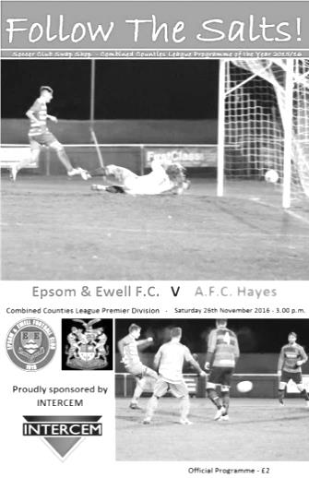
Indiscipline costs Salts two points

Let me say right at the outset that our opponents played well yesterday and were fairly close to us for the entire 90 minutes. As such, a draw is not an entirely unfair result. However, letting a two goal lead slip with less than ten minutes to play against a team that were missing their leading scorer and who hadn't managed a shot on target in the previous 85 minutes leads me to report this as one of our more disappointing days at the office.

The indiscipline in conceding twice from a seemingly impregnable position is particularly frustrating, especially after we had worked so hard to establish a lead against a team that belied their current league position and fought for everything. Another area of major concern relates to the enforced substitution of two of our better players for their own protection after picking up early dissent bookings. We now have four seperate players with at least five bookings to their tally and we have only played 25 matches all season! Our own supporters keep telling me that we are not a dirty team and I would agree, despite an enormous 21 player sending offs in two and a half seasons. However, in an era where organisations are coming down hard on respect offences, we do not seem to have learned the simple fact that a referee, no matter how erratic their decisions, will not change his mind after making one, and you also have to question whether a referee or Assistant who is getting grief from a player is going to feel more or less likely to give them the benefit of a borderline decision in the remainder of the game.

We made two changes to the starting eleven with Adam Heagney coming in at the back and James Taylor moving alongside Dan Dean in the absence of Craig Hastings. Additionally the absence of Jason Nwachukwu meant that Agi Panayiotou moved into an advanced midfield role with Alex McKay coming back in to take the holding role.

Both teams started by pressing the opposition and we had a high tempo first half, although the competitiveness ensured that there were few chances created as a result. We had one in the 10th minute first opportunity came after Daryl Cooper-Smith was tackled on the edge of the area. The referee gave us a most generous free kick but from the edge of the area Matt Ferdinando dragged his effort wide of the far post. A minute later Ferdinando showed great skill to beat two men and get down the right inside the penalty area, but with Cooper-Smith waiting in space he scuffed his cross and the danger was cleared.

Ferdinando then talked his way into the book after 20 minutes but we continued to press forward and a Panayioutou corner went straight through everyone at a decent height and out for a goal kick before a good ball to Cooper-Smith enabled him to send Jordan Gallagher down the right wing, but the visiting keeper Cameron Kennedy was out quickly to block the cross.

The visitors tried a long shot from distance that was well wide and that was the sum total of their attacking efforts for the first half. Unfortunately Cooper-Smith was then pulled up for a handball and found himself in the book for his comments. This was his fifth yellow card and earns him a suspension. When that comes through we will miss his all round play and clinical finishing, an example of which was shown in the 40th minute. A superb ball into the left hand channel enabled him to get ahead of his defender, and he then held off the challenge as he came in form the angle before rolling the ball beyond Kennedy and into the far corner as calm as you like. This was his 20th goal in twenty appearances this

season, a superb achievement.

There was further pressure as Dean had a low shot from thirty yards out which required Kennedy to make a decent save and just before half time a Taylor looping header to the far post required a defensive header out for a corner.

The second half started with another erratic decision from the referee who awarded us a free kick before deciding that the foul was in fact the other way and awarding it to the opposition. Soon after this he pulled up the visitors for their third foul throw of the afternoon. This was breaking up play and not allowing either team to gain momentum and it took time before a decent attempt on goal occurred, wth a Ferdinando free kick finding McKay in space but he glanced his header at goal when he probably should have headed across goal to the waiting Cooper-Smith and Matt Farrell and Kennedy made the save.

We had a shout for a penalty when Cooper-Smith appeared to dink the ball past a player only to then be upended by a firm challenge that also got the ball, although it was difficult to tell which the defender had got first. However, it was inexplicable to see the award of a goal kick given instead. We then had a couple of minutes stoppage as the visitors Captain Daniel McDonnell had gone down across the other side of the field and when he eventually limped off it was clear that he had damaged his arm or collar bone. That injury time would come back to haunt us later.

Panayiotou made a good run but his shot was blocked by a good defensive challenge and Cooper-Smith then put him through a minute later but his attempt from the edge of the area was also well blocked by a combination of defender and keeper alike. However, he would not be denied and when Cooper-Smith set him up around the penalty spot, he held off the challenge and smashed the ball right into the top corner to give us a two goal lead in the 66th minute.

Within a minute of the goal Reisse Griffin and Rob Hendry had replaced Cooper-Smith and Ferdinando. McKay hit a powerful strike at goal from 30 yards but it was well blocked before Hendry almost scored an outrageous goal from 25 yards out wide; his shot just clearing the bar. Gallagher was then unfortunate as he met a Griffin cross with a header that beat Kennedy but hit a defender and went out for a corner.

We earned another corner after a low set piece from Hendry was sliced just over his own bar by a defender and almost scored again after a deep cross from Griffin was volleyed by Panayiotou back into the path of Gallagher but he was unable to make a solid contact and the shot was saved by Kennedy. It would have been a special goal if it had worked out.

But maybe because we couldn't finish them off, and conscious of the fact that they had recovered a two goal deficit only four days previously, the visitors switched to three at the back with impressive left back Harry Bishop pushing forward and the momentum of the game changed. Griffin conceded possession in the middle of the field in the 85th minute and the ball was fed in to our danger area. We were unable to clear our lines and the ball was struck past Michael Eacott from about twelve yards out by Joshua Quadry. We then had a concern after an indirect free kick was awarded just eight yards out against Eacott but fortuntately the visitors made a right hash of it, with the end result of a goal kick.

However, any thoughts that we might hold on were ended after a corner was flicked on to the far post where I am informed that substitute Dale Kennedy got the final touch to score the equaliser with the clock showing the 93rd minute. Further delays then occurred as the goal led to a coming together of both benches and there were further arguments as the players went off at the end. How did it come to this? Simply because we gave the opposition a life line and they took it. We have been quite clinical recently so maybe this was a rare instance. One thing is certain. With two big cup matches followed by two tough matches against teams in the top three we have to learn from this experience and also to find a way to stop picking up so many unnecessary cards.

Epsom and Ewell: Michael Eacott, Adam Heagney, Matt Tanton, James Taylor, Dan Dean ©,
Alex McKay, Jordan Gallagher, Matt Farrell, Daryl Cooper-Smith, Savvas 'Agi' Panayiotou,
Matt Ferdinando
Subs: Reisse Griffin for Ferdinando (67), Rob Hendry for Cooper-Smith (67),
Daniel Rose for McKay (77)

From behind the goal
Worcester Park 3-6 Epsom & Ewell
Combined Counties League Cup – Third Round - Saturday 3rd December 2016

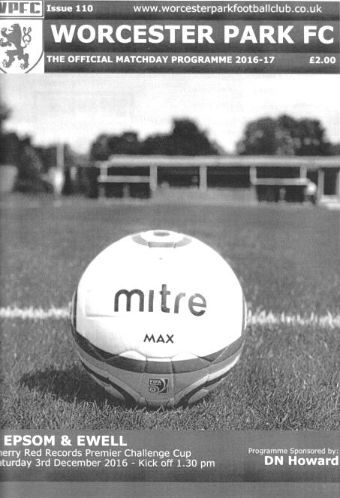
Salts ease to cup tie victory in Green Lane goal riot

When considering that the home side had scored a substantial number of goals in establishing a winning run of eight straight matches, and that our team had four players out suspended, this match was actually a lot more comfortable than many of us thought it would be, and in all honesty we could have had ten by the end.

With Matt Farrell, Dan Dean, Reisse Griffin and Matt Ferdinando all suspended for this match and Jason Nwachukwu nursing a sore ankle it was time to find out how strong our squad was, and the answer was a very positive one. Daniel Rose came in for Farrell, while Rob Hendry and Craig Hastings also returned to the starting eleven. Of course it also helps when you have a striker in fine form and Daryl Cooper-Smith scored four of our six goals today to bring his tally to 24 in just 21 matches this season. The last person to score four goals in a match for us was Portuguese striker Joao Tome on 8th September 1998 and you have to go further back to the fifties before you find Epsom strikers scoring at a rate of over a goal a game. In under two years at the club he stands just one goal away from joining the top 30 goal scorers in our history.

Of course, a striker is only as good as his service and he was well supported all day, particularly by Jordan Gallagher who had his own hat trick of assists, while Agi Panayiotou scored the other two goals in a match where we took charge early on and didn't let up in any way until we were 5-1 ahead.

The first real chance came from the home team as they hit the post in the seventh minute but we took the lead in the ninth. Gallagher got down the left and although the delivery was half cleared, Cooper-Smith collected the ball just inside the box and fired low past Kevin Wheeler in the home goal. We continued to press and James Taylor flicked on a free kick beyond the advancing Wheeler but wide of the goal where Cooper-Smith was on it first but was at a narrow angle and found his shot blocked by the recovering keeper.

It made no real difference though as we extended our lead in the 17th minute anyway. Rob Hendry pinged the ball forty yards from right to left where Gallagher took the ball perfectly in his stride, eliminating his defender in the process and squaring the ball to the far post

where Cooper-Smith forced the ball in from close range. Three minutes later I nearly had to consult the record books for quickest hat trick as he controlled a ball over the top and rounded Wheeler at the same time, but a defender blocked his attempt and although the ball then fell back to him, Wheeler managed to smother the ball out for a corner.

Alex McKay then had a header on target from the Gallagher corner before being involved again, flicking on a Matt Tanton free kick to Cooper-Smith but from a good position his low shot grazed the outside of Wheeler's left hand post and out for a goal kick. Despite all of this the home side then opened their account in the 31st minute when a deep cross from the left wing was clawed away by Ali Turpie in our goal but our defenders were unable to react to the loose ball and it was fed back in to Simon Burt who was able to score from close range.

This was harsh on our boys but the two goal lead was restored three minutes later when Hendry put Panayiotou through and although his shot was half saved, it still had enough momentum to cross the goal line before a defender was able to reach it. The half ended with long distance attempts from both sides and we were well worth our 3-1 lead at the break.

Heading towards the station end for the second half we scored our fourth goal within six minutes of the restart when Cooper-Smith slid the ball in for Panayiotou to score his second goal of the day from close range. We should have extended our lead further after a brilliant deep crossfield pass from Tanton into Cooper-Smith's path but he went for power and drove the ball just beyond the far post from twelve yards. Cooper-Smith then glanced a Gallagher free kick on target only to see Wheeler get down low to turn the ball around the post.

We made it 5-1 in the 64th minute after a great pass down the left to Gallagher, who then cut back inside his defender and crossed low to the far post where Cooper-Smith killed the ball before finishing off from close range.

Soon after that we had a pleasant surprise as Ali Dewar made his first appearance for us since a Surrey Senior Cup tie at Molesey in January 2015, although the home side reduced the arrears in the 67th minute with Joe Cheeseman sending a looping header over Turpie from a left wing cross. In response Gallagher tried to score after a good run but his shot was not powerful enough to test Wheeler with Cooper-Smith waiting in acres of space nearby. He might have been regretting his decision to shoot instead of pass when the home team reduced the deficit to 3-5 shortly after this through a close range finish from Johnny Phillips which was defended quite poorly.

At that point McKay was replaced by Assistant Manager Matt Smith who nearly made it two goals from two cameo appearances for the season but sent a free kick from an angle just beyond the far post but we scored again as Cooper-Smith latched on to a ball through the middle and rounded Wheeler to register his fourth and our sixth in the 89th minute.

In all honesty this looked like a real banana skin fixture, especially with the suspensions going into this match and with many supporters recalling our previous visit to Green Lane, a 4-1 defeat in January 2012, but by the end the scoreline of 6-3 flattered the home side as it was never really as close as that. We now visit either Sutton Common Rovers or Walton & Hersham in the Quarter-Finals at some point in the New Year.

Epsom and Ewell: Ali Turpie, Adam Heagney, Matt Tanton, James Taylor, Craig Hastings,
Alex McKay (c), Rob Hendry, Daniel Rose, Daryl Cooper-Smith, Savvas 'Agi' Panayiotou,
Jordan Gallagher

Subs: Ali Dewar for Hastings (66), Matt Smith for McKay (79)

Chipstead F.C. – History
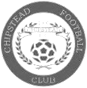
Chipstead Football Club was formed in 1906, when the Netherne hospital was being built and the building workers and the lads in Chipstead challenged each other to a match. The oldest club records dated 1911 show a far from healthy position, survival relying mainly on the proceeds of whist drives. The club’s health began to improve and in 1920 it even had its own transport for away games, an open topped lorry owned by a local builder!

Up to the 1962/63 season Chipstead played junior football but having ﬁnished runners up in the County Junior Cup the previous year they then moved into the Surrey Intermediate League. The club played at this standard until 1982 when they became founder members of the Surrey Premier League.

The next four years saw the club have great success ﬁnishing Runners up three times and also winning the League Cup on three occasions. During this period they were also beaten ﬁnalists in the County Premier Cup. The Reserves also met with success being Runners up once and also winning the League Cup.

After a long battle the club were awarded senior status in 1986 and were promoted to the Combined Counties League where once again success followed, a League Championship was gained in 1989/90 and Runners up spot was gained on two occasions, six League Cup Finals with Chipstead being victorious in four.

Season 1987/88 saw the club make its debut in the F.A. Vase and the following year in the F.A. Cup. Over recent years the club has continued to grow and strengthen its youth policy with some 200 players between the ages of six and eighteen involved every week. One of our ex-youth players, Steven Sidwell is playing in the Premiership at Stoke City.

Our 2006-07 Combined Counties Championship winning squad contained no fewer than 12 players who had represented the club at youth level. In 1998 Chipstead were able to purchase the freehold of the ground from the Local Authority and in 2001, thanks to a grant from the F.A., the club was able to purchase additional land, which was developed into Mini soccer pitches to further enhance the youth policy.

More recently, in November 2004, a 100-seater stand was installed which was increased to 150 in March 2007. In May 2006 a covered standing area for 150 people was erected.

2006-07 was our ‘Centenary Season’ and the hope was that it would be a memorable one. On the opening day of the season the team won their ﬁrst game and went top of the table. Come February and still top, the decision was made to do the necessary work to achieve the ground grading. The next six weeks saw the ground transformed thanks to the incredible hard work of the committee and supporters. The team remained top and promotion to the Ryman’s league was achieved for the ﬁrst time in 100 years.

In the 2007-08 season the seniors won the Southern Combination Cup beating Ryman Premier side Ashford Town (Middx.) in the ﬁnal. In 2008-09 season the club reached the 4th qualifying round of the FA Cup for the ﬁrst time, eventually being beaten at Torquay United 1-4.

In 2010-11 the club ﬁnished 10th in the Ryman Division One South, our highest ever position in the football pyramid but 2012-13 was a poor season for the club with no fewer than 4 managers. Mark Tompkins left the club just one game into the season, his assistant Mick Read acting as temporary manager for a month before the club appointed John Hamsher. Things seemed to be ﬁne until January when results took a dip. John decided to step down in early April. Vice Chairman Mick Ford took over the reins for the ﬁnal 3 matches of the season.

2013-14 saw Chipstead start with a new management team, Kevin Rayner, Roly Martin his assistant and Mark Elgar as technical assistant. After a poor run of results, Mick Ford took over as Chairman and appointed a new 1st team Manager, Steve Baker. A mid-table ﬁnish of 13th was a great turnaround for the club. Steve left the club in 2014-15 and was replaced by Simon Colbran.

2015-16 Following a poor start to the season, Simon resigned and was replaced by Lyndon Buckwell. Unable to turn things around, Lyndon himself was replaced by Craig Tanner who ultimately managed to save the club from relegation with a few games to spare. Craig then parted company with the club during the summer so we look forward to what we hope to be a more settled season than last under the management of former Chipstead player Anthony Williams. Come on the Chips!

Combined Counties League Premier Division Opponents
All-time Records
incl Saturday 3rd  December | P | W | D | L | F | A | PPG | GD | Best  Win | Worst  Loss
Bedfont & Feltham | 1 | 1 | 0 | 0 | 9 | 2 | 3.00 | +7 | 9-2 | X
Spelthorne Sports* | 5 | 4 | 1 | 0 | 15 | 6 | 2.60 | +9 | 6-2 | X
Sutton Common Rovers | 11 | 9 | 1 | 1 | 29 | 13 | 2.55 | +16 | 4-0 | 1-4
Horley Town | 29 | 20 | 5 | 4 | 65 | 30 | 2.24 | +35 | 6-0 | 1-3
Colliers Wood United | 22 | 14 | 2 | 6 | 45 | 33 | 2.00 | +12 | 4-0 | 0-5
Bedfont Sports | 10 | 6 | 2 | 2 | 18 | 11 | 2.00 | +3 | 5-1 | 0-4
Abbey Rangers | 3 | 2 | 0 | 1 | 10 | 4 | 2.00 | +7 | 7-1 | 2-3
Westfield | 19 | 11 | 3 | 5 | 40 | 31 | 1.89 | +9 | 6-1 | 0-4
Farnham Town | 14 | 8 | 2 | 4 | 25 | 23 | 1.86 | +2 | 3-1 | 1-4
Knaphill | 7 | 4 | 1 | 2 | 15 | 8 | 1.86 | +3 | 4-0 | 1-2
Guildford City | 17 | 10 | 1 | 6 | 34 | 22 | 1.82 | +12 | 5-1 | 1-5
Hanworth Villa | 15 | 8 | 3 | 4 | 38 | 26 | 1.80 | +12 | 5-0 | 1-4
Raynes Park Vale | 27 | 13 | 6 | 8 | 58 | 37 | 1.67 | +21 | 6-1 | 0-2
Badshot Lea | 18 | 8 | 3 | 7 | 35 | 34 | 1.67 | +1 | 4-1 | 0-4
Walton & Hersham | 50 | 24 | 10 | 16 | 101 | 97 | 1.64 | +4 | 6-0 | 0-8
Camberley Town* | 89 | 38 | 22 | 28 | 158 | 123 | 1.52 | +35 | 9-1 | 0-4
Hartley Wintney | 10 | 4 | 3 | 3 | 25 | 17 | 1.50 | +8 | 5-0 | 2-4
Windsor | 49 | 19 | 12 | 18 | 90 | 90 | 1.41 | -2 | 4-0 | 0-6
Chertsey Town | 47 | 17 | 5 | 25 | 70 | 86 | 1.19 | -16 | 3-0 | 0-7
AFC Hayes | 9 | 2 | 3 | 4 | 18 | 17 | 1.00 | +1 | 7-0 | 0-3
North Greenford United | 11 | 3 | 2 | 6 | 15 | 20 | 1.00 | -5 | 3-0 | 1-4
CB Hounslow United | 2 | 0 | 0 | 2 | 2 | 7 | 0.00 | -5 | X | 1-5
* includes one abandoned match v Camberley and one loss on penalties v Spelthorne

Dave Wilson Trophy Review
Since Dave Wilson’s untimely death in 2006 the club has run nine Tournaments in his memory. Some have been four team events while circumstances have sometimes meant that others have been restricted to individual matches.

Here is a summary of all nine of the previous tournaments:
A minute’s silence at Merstham F.C.in the match following Dave’s passing on 16th Sept 2006

Dave Wilson Trophy I – 31st July – 4th August 2007
The inaugural tournament took place on a four team basis, based on two semi-finals over the week, followed by two matches on Finals day; a third place play off and a Final. With no extra time, this has been the format for all of the four team events that have followed. This was particularly relevant in the very first Trophy as three of the four matches were decided by penalties.

The first match took place on the 31st July between Banstead Athletic and Corinthian Casuals. Although conceding an early goal, Banstead went on to win 6-3 and secure their place in the final. Two days later we faced Molesey and although Chad Heuston put us ahead after 43 minutes, Molesey equalised on the hour and after the game had finished at 1-1, they won 5-4 in the shoot-out.

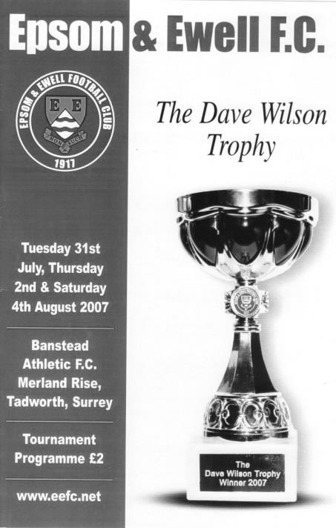
The third and fourth place play off between Epsom and Corinthian Casuals took place the following Saturday. This time we trailed but a late Kyle Hough equaliser earned us penalties, although we were unable to take advantage of the reprieve and again lost by the same 5-4 margin.

It was next the turn of Banstead and Molesey to contest the final. Following a 2-2 draw the new trophy was decided by the drama of yet another penalty shoot-out, which Banstead comprehensively won 4-1.

Everyone agreed that it had been a successful event, allowing many players and supporters to meet up again after an absence of some years. It was resolved to continue it for future years.

Dave Wilson Trophy II – 29th July – 2nd August 2008

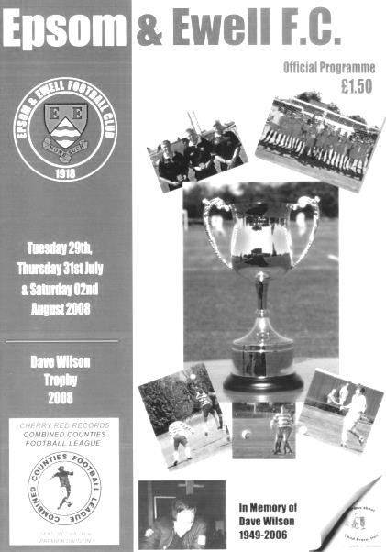
The second season of the competition was successful as we lifted the trophy, following a penalty shoot-out win over Banstead Athletic in the Final.

It kicked off on Tuesday 29th July 2008 with Epsom & Ewell playing Molesey, where we retrieved an early deficit in their Semi-Final with an equaliser by Robbie Burns seven minutes from half time, while a 54th minute penalty by Kyle Hough won the game 2-1.

In the other Semi-Final two days later, holders Banstead Athletic edged past Dorking 1-0 to ensure another landlord v tenant battle. In the third place play off, Molesey defeated Dorking.

The Final on started badly, as a defensive slip allowed their opponents to take an early lead, while at the other end a Banstead defender headed the ball onto his own crossbar. The Blues hit the bar again in the second half, but by that time they were already level from a Chad Heuston downward header bouncing up into the roof of the net from a Kyle Hough corner.

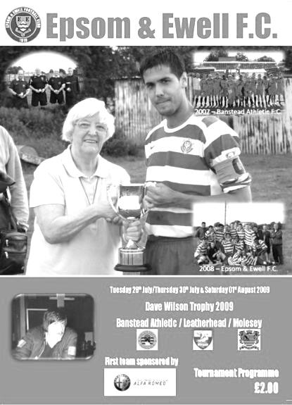
Despite having the better of the match, the tie went into penalty kicks as the match finished 1-1. Supporters were aware that the club had never won a penalty shoot-out in their history, never mind the two losses this year in the same tournament, but this time it was different as the Blues came through 3-2 with no requirement for them to even take the final penalty.

It would have been easier still if the Assistant Referee not taken exception to two stunning Paul Borg saves that he decided the keeper had wrongly ventured from his line to reach.

Dave Wilson Trophy III – 28th July – 1st August 2009

The third Dave Wilson Trophy kicked off with Molesey defeating Banstead Athletic by two clear goals to reach their second final, while we faced a tough encounter with Leatherhead, where despite trailing 2-0 after 25 minutes we pulled a goal back and missed chances to equalise before our opponents scored twice in a minute just before half time to lead 4-1 at the break. With little to play for except pride in the second half, we reduced the arrears to 4-3 with goals from Ross Shoefield and Robbie Burns getting his second of the match but a fine fifth goal killed off the resistance and the Tanners progressed by five goals to three.
In the third place play off we defeated Banstead Athletic 2-1, although we again trailed early and did not equalise until the second half through Mu Mann

after a good run from Dale Marvell. Our winner came in the 70th minute when Robbie Burns finished off Marvell’s set up and we were to finish in third place.

The final was infinitely more interesting. Molesey were clear underdogs against Leatherhead and when they went two-nil up after less than ten minutes, the writing was on the wall. However, the Moles pulled a goal back before half time and equalised after 72 minutes, leading to our third straight penalty shoot-out in a Final.

This time Molesey held their nerve and won 5-4 to become the third different winners of the trophy.

Dave Wilson Trophy IV – 31st July 2010

The 2010 competition was the first to be played away from Merland Rise, following the termination of our ground share arrangement that summer.

However, what looked like being a four team tournament at our new ground share in Merstham eventually ended up as a single match against Molesey, played on a private pitch at Goals, Tolworth!

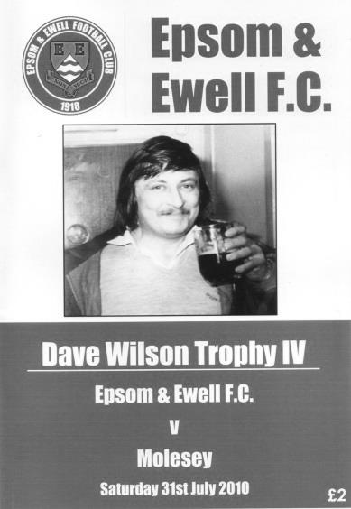
Molesey retained the trophy with a 1-0 win; a superb strike from Sam Lampard in the 18th minute, but the tournament lacked as a result.

Dave Wilson Trophy V – 27th July – 30th July 2011

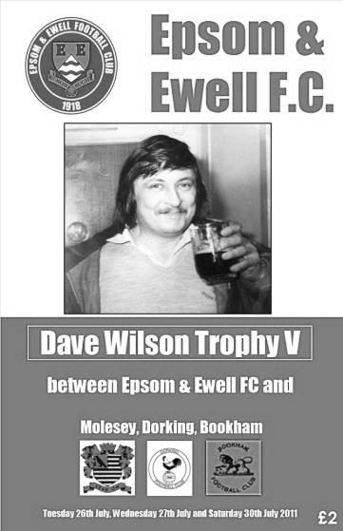
The Club Committee were very keen to get the tournament back to its four team format, although again Merstham were unable to accommodate us. Fortunately, through the generosity of Dorking we were able to host the tournament at Meadowbank.

As holders, Molesey were invited, while hosts Dorking and local friends Bookham made up the four teams.

On paper this looked like it would be a Molesey v Epsom & Ewell Final but football doesn’t always work like that and it turned out that the two teams would meet in the Third place playoff instead!

We met Bookham on the Tuesday evening and held most of the possession without doing enough to score. Then midway through the second half we conceded twice in two minutes and although we got one goal back through a Dave Francis header, we were unable to force penalties.

The other game did go to penalties after a 1-1 draw but the hosts won on penalties.

In the third place play off we thrashed Molesey 5-1 with a couple of goals from Alex McGregor, added to strikes from Michael Morgan, Dave Francis and Ayden Richards but the final was an anti-climax as Dorking also had a friendly arranged elsewhere and Bookham deservedly beat them 1-0, although it required an 86th minute goal from Renton-Race to break the deadlock and he then

skied a penalty right at the end, but the trophy was theirs anyway.
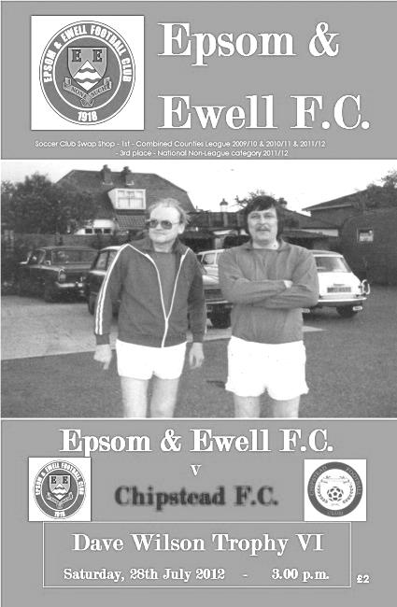
Dave Wilson Trophy VI – 28th July 2012

The sixth running of this tournament was held at our new “home” of Chipstead F.C. but regrettably was just a one match format again, this time against our hosts.

The first half was a tame affair with only a superb thirty-five yard strike for Chipstead in the 19th minute separating the teams. However, the substitution of Mark Jarman sparked things into life and he brought us level after 55 minutes although the greens had the final say, scoring the winner after 76 minutes with a close range header.

Dave Wilson Trophy VII – 23rd July – 27th July 2013
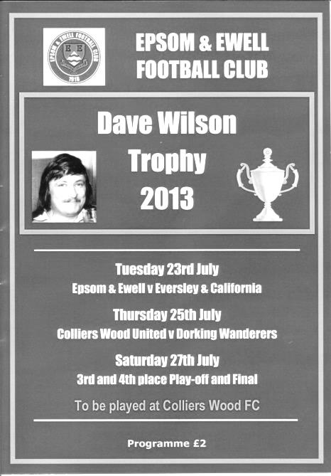
Colliers Wood United generously provided the venue for the seventh Dave Wilson Trophy, which enabled the club to revert to the preferred four team tournament. Along with our hosts, the other two teams were new to the tournament, Dorking Wanderers from the Sussex League and Eversley & California from the division below us.

We met Eversley in the opening match but trailed after just 18 minutes. We fought back but chances weren’t taken and their lead was extended in the 59th minute. Nathan Ayling replied with a long range effort moments later but as we pushed for the equaliser we were caught on the counter attack and lost 3-1.

Colliers Wood United then proved fitter than Dorking Wanderers as they won 7-2 in the other Semi-Final after the game was tied at 2-2 at one stage.

So it was back to the third place playoff for our boys again and an uninspiring goalless draw against Dorking Wanderers was followed by a 3-1 penalty shoot-out win with Reece Jackson providing the highlight with a “Panenka” style penalty.

But this wasn’t really a penalty shoot-out. Not compared to what followed as Colliers Wood United looked set for victory as they went 2-0 up after 66 minutes but two goals from Baker after 80 and 89 forced what would prove to be the longest penalty shoot-out in Dave Wilson Trophy history with both teams missing their third kick but scoring all the others until the hosts missed their eighth and Eversley triumphed by a score of 7-6!

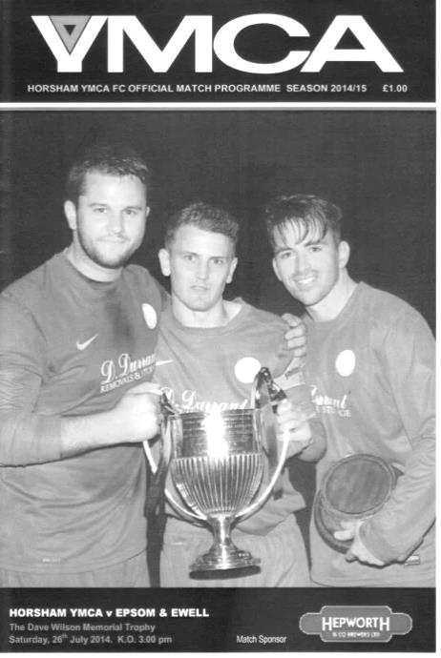
Dave Wilson Trophy VIII – 26th July 2014

The eighth Dave Wilson Trophy actually took place in Sussex as we visited Horsham YMCA for a single match, winning by five goals to two to win the trophy for a second time.

It was a fine performance as we cut the opposition to ribbons at times, leading 2-0 at the half, and even allowing for a lapse that left the hosts level at 2-2 we ran away with it in the second period as we scored three more times to win 5-2. Our scorers this day in a match restricted to forty minutes each way were Taylor Smith, Matt Farrell, Karl Douglin and Alex Tilly.

Dave Wilson Trophy IX – 4th August 2015

The latest Dave Wilson Trophy took the shape of our final pre-season friendly at High Road against our landlords Chipstead F.C. as it had three years previously. However, this time we would win by the odd goal in three despite being behind at the half again as the greens scored in first half injury time. Goals from Reisse Griffin and Kyle Hough just either side of the hour mark were sufficient to turn the match around, although we had been the better side throughout and enabled us to claim the trophy for the third time.

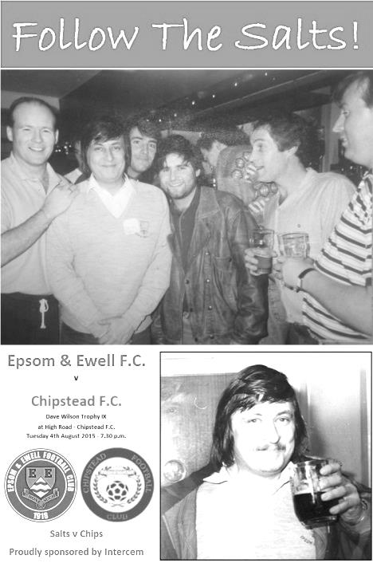
So as it stands, we currently hold the trophy and it is hoped that once we secure a new ground we will be able to host these tournaments in a grander manner. For now though the trophy, like our team, retains a nomadic existence but reaches the significant mark of its tenth tournament tonight, with the added bonus of being a Surrey Senior Cup tie against Chipstead.

It is quite an achievement that we have been able to maintain this event over the difficult years and I’m sure that although Dave would be somewhat embarrassed by the attention created by a trophy in his memory, he would also, I’m sure recognise the work that has been put in to keep it going, and here’s to the next ten years!

Club Records - 6th December
Date | Day | Competition |  | Opponents |  | Scorers
06/12/24 | Sat | Surrey Senior League | A | Leyland Motors | 2-1 | J.Parr, R.Sperring
06/12/30 | Sat | Surrey Senior Cup 3q replay | H | Camberley & Yorktown | 4-1 | T.Jones (2), B.Earl (2)
06/12/47 | Sat | London League | H | Guildford City Reserves | 0-2
06/12/58 | Sat | Corinthian League | A | Edgware Town | 2-2 | T.Higgins, T.Millard
06/12/69 | Sat | Athenian League 2 | H | Hemel Hempstead Town | 0-2
06/12/75 | Sat | Athenian League 2 | H | Faversham Town | 3-0 | B.Denman, T.Coombe, o.g.
06/12/80 | Sat | London Senior Cup 3q | A | Hampton | 2-3 | T.Tuite, S.Delaney
06/12/86 | Sat | Isthmian League 1 | H | Walton & Hersham | 2-1 | T.Tuite, J.Stainer (pen)
06/12/97 | Sat | Isthmian League 3 | A | Lewes | 2-1 | A.Boxall (2)
06/12/03 | Sat | Isthmian League 1s | H | Bromley | 1-1 | J.Buckley
06/12/05 | Tue | Surrey Senior Cup 1 | A | Ashford Town (Mx) | 1-3 | R.Ingham
06/12/08 | Sat | Combined Counties  Premier Division | H | Horley Town | 0-0
06/12/11 | Tue | Surrey Senior Cup 2 | H | Sutton United | 0-1
Historical Decades
Date | Day | Competition |  | Opponents |  | Scorers
90 years ago – Epsom Town F.C.
04/12/26 | Sat | Amateur Cup 4q | H | Wimbledon | 1-3 | R.Coleman
80 years ago – Epsom F.C.
05/12/36 | Sat | London League | A | Finchley | 1-7 | T.Rochester
70 years ago – Epsom F.C.
07/12/46 | Sat | London League | H | R.N.Depot | 4-0 | G.Brogdale (2), R.Allsop (2)
60 years ago – Epsom F.C.
08/12/56 | Sat | Corinthian League | A | Worthing | 1-0 | J.Bangs
50 years ago – Epsom & Ewell F.C.
03/12/66 | Sat | Athenian League 2 | A | Marlow | 2-7 | T.Williams, C.Spriggs
40 years ago – Epsom & Ewell F.C.
11/12/76 | Sat | Surrey Senior Cup 4q | A | Redhill | 5-0 | T.Tuite (2), K.Eshelby, A.Webb, A.Reid
30 years ago – Epsom & Ewell F.C.
06/12/86 | Sat | Isthmian League 1 | H | Walton & Hersham | 2-1 | T.Tuite, J.Stainer (pen)
20 years ago – Epsom & Ewell F.C.
07/12/96 | Sat | Isthmian League 3 | H | Wealdstone | 2-3 | M.Jones, S.Smith
10 years ago – Epsom & Ewell F.C.
09/12/06 | Sat | Combined Counties  Premier Division | A | Camberley Town | 1-0 | A.Pero

History Corner – 6th December
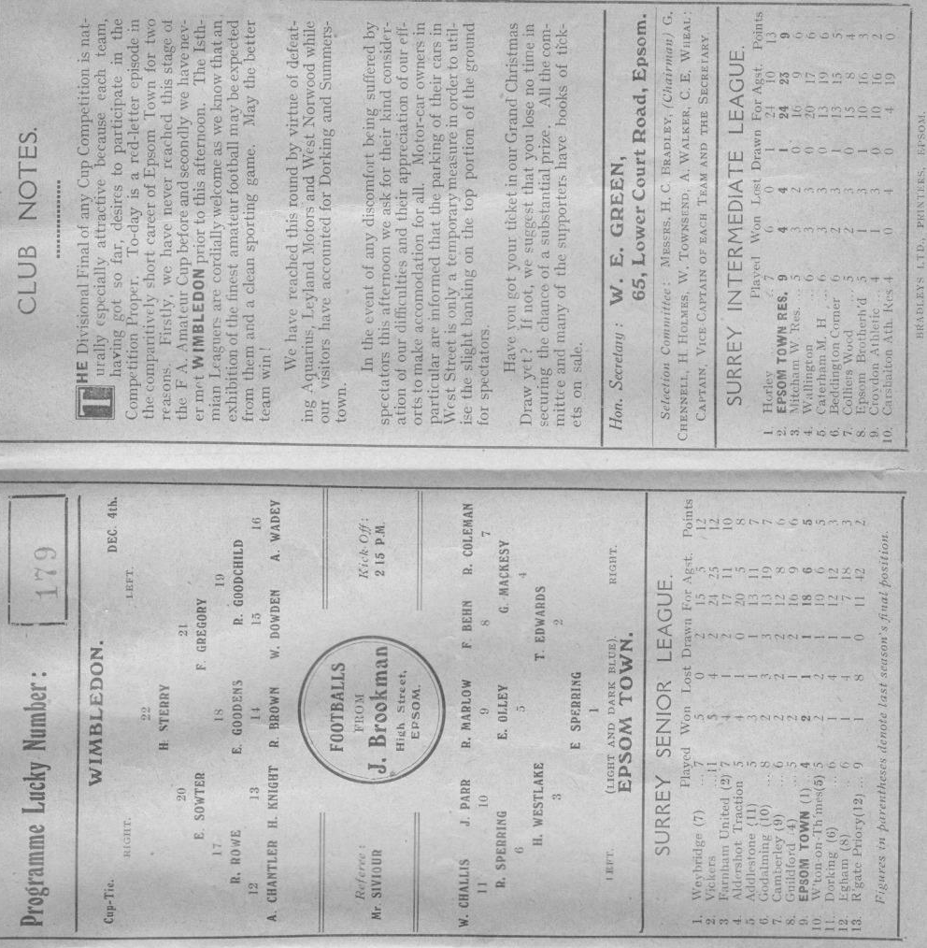
90 years ago this week we hosted the mighty Isthmian League Wimbledon for the first ever time in our history for the final qualifying round of the Amateur Cup. Following wins over Aquarius, the Water Board Works team, Leyland Motors and West Norwood, we pulled out the biggest name in our area.

Why it was that a club so large actually needed to go through the qualifying rounds, I am unsure but we were ready to have a go at them, and the match was to take place at West Street, following our club declining the Dons offer to switch the match to Plough Lane for a larger gate and the finance that would come with it. As it was, the Surrey Comet advised that 4,500 people crammed into West Street, and although the Epsom Herald and Advertiser were more cautious with figures just over the 3,000 mark, the club later referred to the attendance as one of 8,000! If it were the case, then it would be the largest attendance ever assembled at West Street, and things looked good as a goal from Reg Coleman gave us the lead at half time.

Despite going down the hill in the second half, we were unable to hold on and the visitors equalised on the hour, with two goals in the final three minutes giving them a 3-1 win.

Centre page for results

Centre page for results

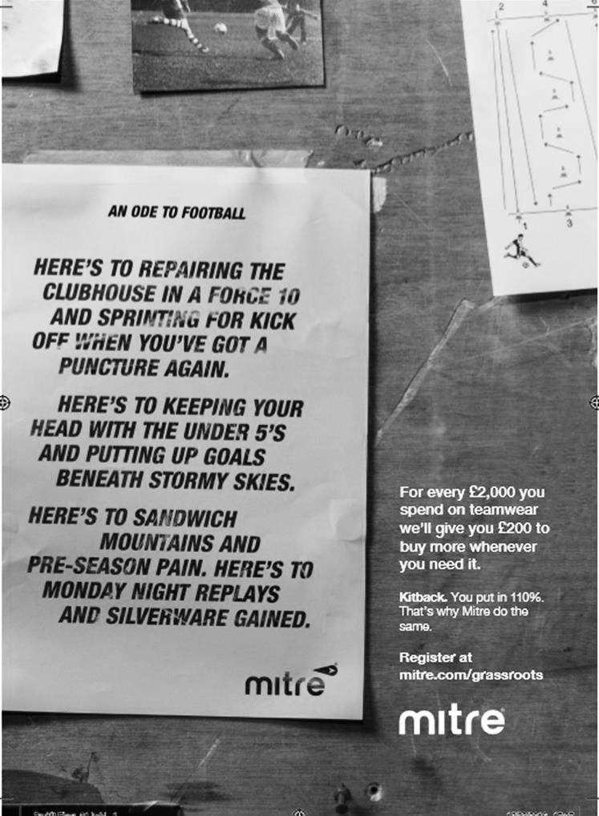

Surrey Senior Cup
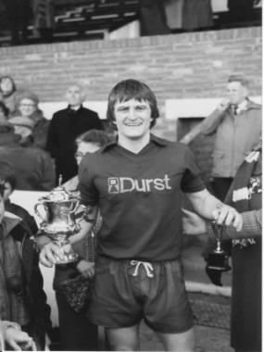
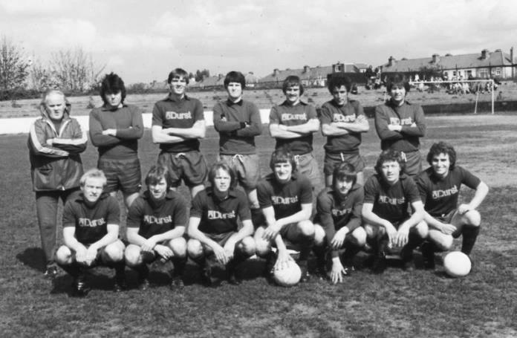
First Round
Abbey Rangers | 4-3 | AFC Croydon Athletic
Whyteleafe | 5-4 | Westfield
Second Round
Met Police | V | Kingstonian
Ashford Town (Mx) | 0-1 | Knaphill
Woking | 4-0 | Walton Casuals
Whyteleafe | 6/12 | Colliers Wood United
Guildford City | 14/12 | Horley Town
Egham Town | 3-0 | Corinthian Casuals
Godalming Town | 6/12 | Merstham
Molesey | 0-1 | Leatherhead
Raynes Park Vale | 6/12 | Sutton United
Sutton Common Rovers | 5-1 | Camberley Town
Dorking Wanderers | 6/12 | South Park
Badshot Lea | V | Farnham Town
Walton & Hersham | 3-0 | Croydon
Carshalton Athletic | 12/12 | Tooting & Mitcham United
Chertsey Town | 2-1 | Abbey Rangers
Epsom & Ewell | 6/12 | Chipstead

Buildbase F.A. Vase
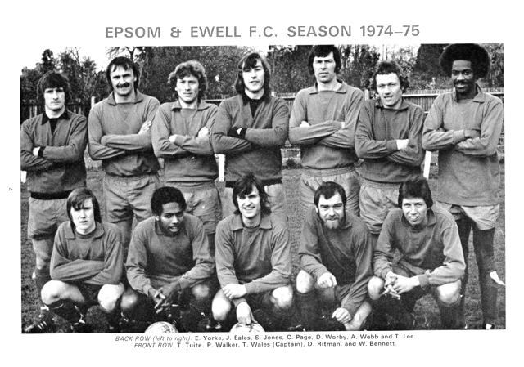

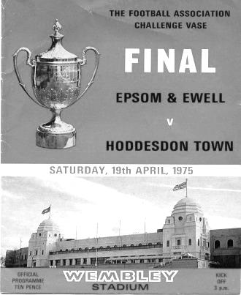
Third Round – 32 ties (Combined Counties League clubs shaded)
North Shields | 1-2 | Shildon
Newton Aycliffe | 2-3 | Morpeth Town
Cleethorpes Town | 2-1 | Bootle
South Shields | 3-0 | Staveley MW
Penrith AFC | 0-3 | Atherton Collieries
Dunston UTS | 1-3 | Sunderland RCA
Bottesford Town | 1-2 | Billingham Town
Hucknall Town AFC | 1-2 | AFC Mansfield
Nuneaton Griff | 0-2 | Bromsgrove Sporting
Sporting Khalsa | 5-5+ | Sleaford Town
Coleshill Town | 4-1 | Westfields
Hinckley AFC | 2-1+ | Quorn
Long Eaton United | 2-4+ | Shepshed Dynamo
Wembley | 0-4 | Peterborough Sports
FC Romania | 1-1+ | Tring Athletic
Newport Pagnell Town | 3-1 | London Colney
Gorleston | Abandoned | Basildon United
St Margaretsbury | 1-3 | Berkhamsted
Sun Sports | 3-1 | Hoddesdon Town
Welwyn Garden City | 2-3 | Ely City
Abbey Rangers | 1-2 | Eastbourne Town
Crowborough Athletic | 2-2+ | Bedfont Sports
Croydon | 3-2 | Glebe
Knaphill | 1-2 | Southall
Newhaven | 1-3 | Chichester
Sutton Common Rovers | 1-4 | Corinthian
Horsham YMCA | 0-3 | Buckland Athletic
Bemerton Heath Harlequins | 2-3 | Melksham Town
Team Solent | 1-0 | Bodmin Town
Bradford Town | 2-0 | Torpoint Athletic
Bristol Manor Farm | 4-1 | Thatcham Town
Exmouth Town | 5-0 | Blackfield & Langley
1-0

Surrey Senior Cup Review
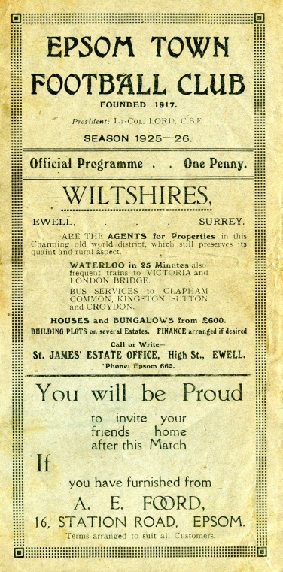
Tonight is our 205th Surrey Senior Cup tie. Over that period we have Won 98, Drawn 20 and Lost 85 with one match abandoned. Our goals in that time are F464 A400. It is also our 104th home tie with 91 being played away from home and ten being at neutral venues.

Our very first Surrey Senior Cup tie was played at Krooner Park, when we defeated Camberley & Yorktown as they were then known by three goals to one on 18th October 1924. We trailed at half time, but two goals from Reg Marlow and the other from Tom Kirk saw us through. A win at Egham gave us a home tie with Weybridge in the first round, but we surprisingly lost this 2-1 at home to end our first County Cup run.

In 1925/26 we started our run with a 3-2 win over Godalming and took revenge on Weybridge by a goal to nil in the next round. This earned us a big match at home to Athenian League Summerstown, who were having a wretched season at the foot of the table, yet they were still two levels above us, and defeated us 4-2 at West Street. (see programme right) The following year was a marathon, as we played six matches but still went out in the first round. We required two replays to dispose of Carshalton Athletic, but minus flu victim Reg Marlow (who was in the middle of his run of five hat tricks in five consecutive matches) we crashed 3-8 at home to Woking.

Summerstown again ended the run 5-1 in the first round in their final season at the Earlsfield Road ground after two wins over Leyland Motors and Aquarius, the Water Board side from Honor Oak, but the 1928/29 season would prove to be the most memorable to date. It didn’t start auspiciously as we were held 0-0 at West Street by the Westminster Bank. We won the replay before knocking out Isthmian League giants Casuals 3-1 at West Street, but the best was yet to come as we humbled Wimbledon 4-1 at Kingstonian’s old Richmond Road ground in the Semi-Final.

The Final ended disappointingly, in front of 4,600 at Guildford City’s Josephs Road ground, we led Redhill at half time with a Bronk Challis goal, but three goals early in the second half changed the match, and a late Bob Earl consolation was not enough as the Lobsters won their first County Cup.

The 1929/30 season was the first time that the Town lost their opening match, away to Tooting Town by four goals to two, but the next season we went all the way to the Quarter-Finals again, by virtue of replay wins over Camberley & Yorktown and Egham. We then earned a trip to Dulwich Hamlet’s old Champion Hill ground, and I mean the first one, not the enormous one that only people over the age of 35 can remember, but the one before that, which was actually to the side of the new ground, behind the big terrace.

In front of 5,000 we dominated the game, despite only winning 3-2 (see programme left) but we would never win at Dulwich again. Mitcham Wanderers ended that year’s run 2-1 at West Street.

For the 1931/32 season the Blues were finally awarded an exemption to the First Round, or last 16, along with the big guns in the County. A Reg Marlow hat trick saw us past qualifiers Wills Sports by 6-2 before Kingstonian made their first visit to West Street since they were present at the opening of the ground, and eased to a 4-1 win in a match that was all over as a contest by half time with the visitors being three goals to the good.

In the thirties we were a very good side. However you wouldn’t have known this from our County Cup performances as we lost in the opening round for four years in a row to, Tooting & Mitcham, Dulwich again, Nunhead and in 1935/36 3-4 at home to Met Police.

So in 1936/37 it was back to the qualifiers, although Banstead Hospital knocked us out in extra time in the final qualifying round. This was a pity as we would have faced our tenants Ewell & Stoneleigh in the next round, but Banstead knocked them out too and actually went all the way to the Semi-Final.
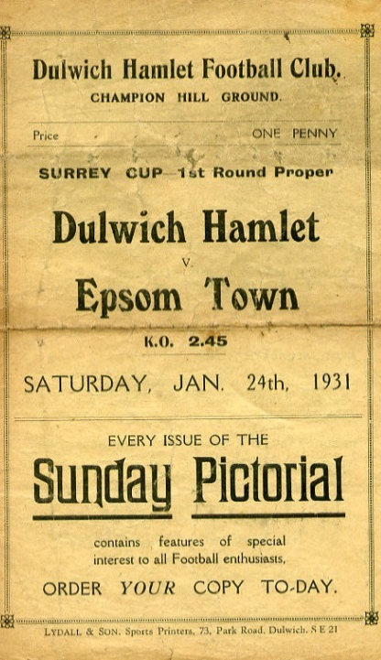
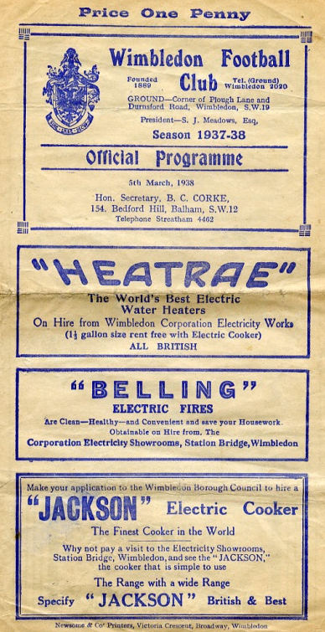
Despite going out in the qualifying rounds we received an exemption to the First Round again for 1937/38. We took full advantage, defeating Met Police 4-1 and Isthmian League Nunhead by five goals to one to reach the Semi-Final against the mighty Dulwich Hamlet. The match was played at the much-missed Plough Lane, Wimbledon see programme right), where goals from Rochester and Bruce ensured a replay at Richmond Road. There we were defeated 3-2 in extra time in a match where Jackie Pullen missed a sitter at the end of normal time with the score 1-1.

The press called it “a tragedy”, and despite Pullen netting in the extra period, we were unable to force another equaliser. It is worth noting that the Hamlet had won the previous year’s competition without conceding a goal, and were looking at repeating this achievement until they came up against us. (see programmes right and over page).

Tooting & Mitcham defeated us 3-2 at Sandy Lane in the opening round of the final pre-war competition During the war, the Cup was played for in 1939/40 by Epsom Town (losing in the Quarter Final to Nunhead), who continued through the war at West Street, before it was held in abeyance for a few years. It returned in 1943 with just nine teams entering, but Epsom Town reached the final, losing to

Tooting & Mitcham 3-1 at Sandy Lane in front of over 5,000 spectators (see programme below). However, the club would never win another match in the competition, losing over two legs to the Magpies again the next year, and to Vickers Armstrong after a replay in their final season of 1945/46.

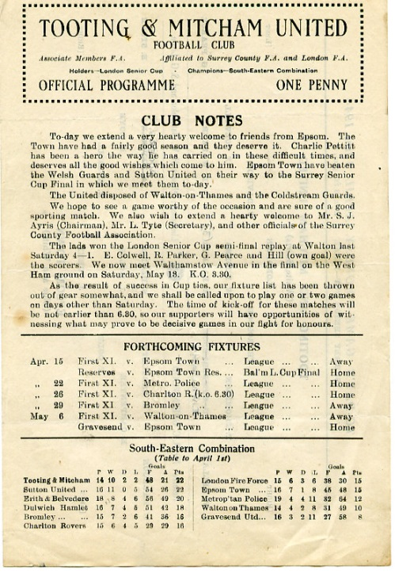
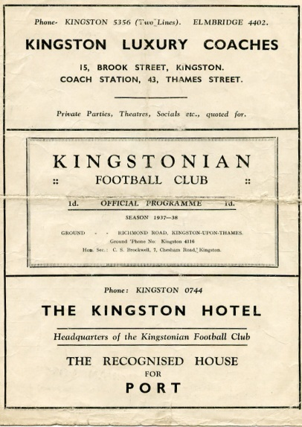
In that season Epsom F.C. defeated Carshalton Athletic 7-3 but were thrashed 6-0 in the Quarter-Final by the newly formed Corinthian Casuals at Richmond Road, where they ground shared with Kingstonian for a spell after the war. Despite reaching the last eight, we then had to play a qualifying round in 1946/47, but crashed out at home to Devas Institute. Oddly though we were back amongst the exempted clubs the following season, but it made no difference as we lost 3-2 at home to Corinthian Casuals again.

In 1948/49 we qualified past Devas (4-0) and Byfleet (6-1) but were defeated by the rising Walton & Hersham team 5-0 in front of 3,000 at Stompond Lane. The following season we were again exempt but Dulwich came away from West Street with a 6-0 win which put us back down amongst the qualifiers again!

It was a bit of a yo-yo really. We were obviously right on the edge of being one of the best eight clubs in the County, as we would rarely get beaten in the qualifiers.

McLaren Sports and Devas were beaten before we beat Hawkers, the Kingston based works side 6-1. Almost! We were nine minutes away from winning before were hit by a massive fog that was so heavy it caused our home Reserve team game to be called off at exactly the same time ten miles away in Epsom, with us leading 4-0 at the time. It was an unfortunate day! We played the following week and edged through 4-3 before again being hammered by Corinthian Casuals, this time 7-1 at West Street.

We were facing a regular scenario. Beat a few average teams before coming up against either Casuals or the Hamlet. For the next three years it would be the latter, winning 4-2 and 4-3 at West Street in consecutive seasons. However, the 1953/54 season would see the tables turned for a change.

Firstly, we received another exemption, for reaching the Quarter-Final the year before, and the draw was kind. We defeated Addlestone and Malden Town without conceding, and faced our nemesis in the Semi-Final at Plough Lane, where a Roy Dymott goal was enough to secure a draw

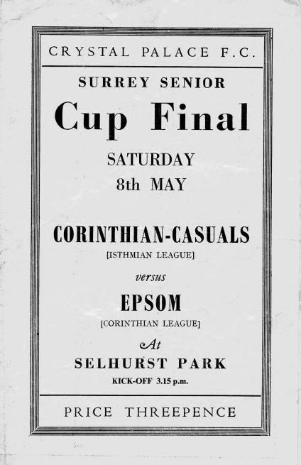
there, just as we had 16 seasons before. This time the replay was at Sandy Lane, where 7,000 witnessed a stunning comeback. We trailed 2-0 with eighteen minutes left, but Gordon Hurst pulled a goal back, and then right on full time as the crowds were beginning to drift away Bill Wiles equalised, with Bobby Avis securing the win with a goal in the second period of extra time. (see programmes above) However, our reward for defeating Dulwich was a Final against Corinthian Casuals! The game was played at Selhurst Park in front of 6,159 and was a let down with our boys conceding once in each half, despite being the better side on the day. (see programme left)

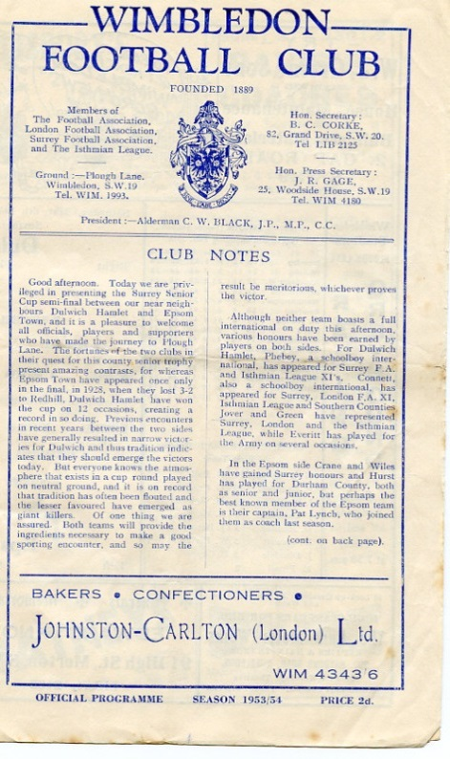
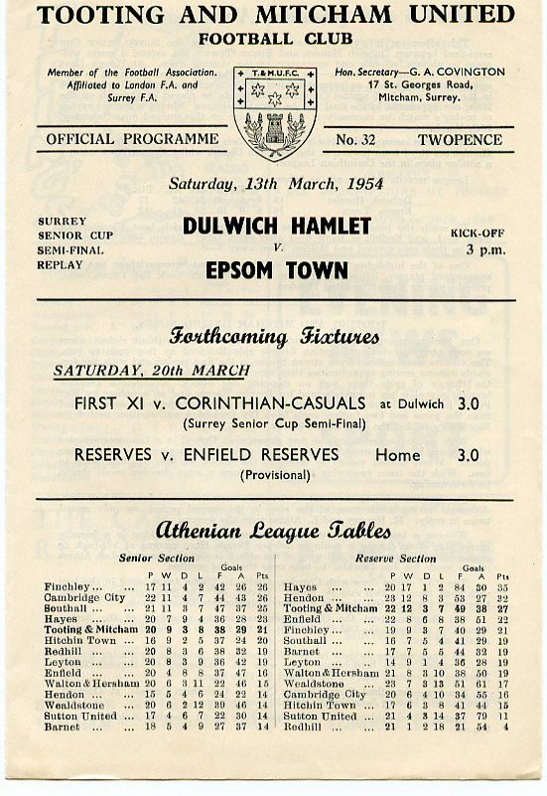
It was Dulwich again in 1954/55 that knocked us out 4-1 and although we edged past Banstead 3-2 on our first visit to Merland Rise, Tooting & Mitcham put us out in 1955/56. The next season was one of our best though, as we battered Kingstonian 5-1 at West Street before then smashing Dulwich Hamlet up 5-3. However, the semi-final brought an unlucky 2-1 defeat to Wimbledon at Sandy Lane.

It seems downright bizarre that we always seemed to

play the same teams, yet never met Sutton United in this competition until 1957, when Johnny Bangs and Jan Sorensen were the scorers in a 2-0 win at West Street. (see programme right). It would be twenty-four years before we would meet again.

In the meantime our luck was about to change for the worse. Woking defeated us 4-2, and then we crashed 5-1 at Dorking in December 1958. This result sent us back to the qualifiers, where we would remain until 1981. As our fortunes plummeted, we only reached the First Round once in the sixties, when wins over Whyteleafe, Chobham (after a replay, awarded because the pitch there was undersized) and Camberley gave us a home tie against, yes, Dulwich again! The attendance of 608 was the best we’d get until the Vase run of 1975 as the visitors won 2-1.

And it was 1975 when we next reached that stage of the competition, slipping up 3-4 at Addlestone, although at 4-0 down we gave them a fright and this helped when we met and defeated them later that season in the F.A.Vase Quarter-Final.

In 1976/77 we reached the First round again, losing 2-1 at home to Walton & Hersham after a replay. This earned us an exemption to the final qualifying round, ahead of many lower league sides, but not quite up with the big boys yet. Tooting & Mitcham and Egham defeated us in the first round in the next two seasons, with Dorking knocking us out in the qualifiers the next year.

In 1980/81 we had a good side, but no one would have expected what happened next. We opened up with a narrow 2-1 win over Westfield before winning 6-0 at Ash United in the First Round. The Quarter-Final drew us at Walton & Hersham and we got a 1-1 draw there, finishing them off in the replay 4-2. Enter Sutton United, who were having a very good season themselves which would end at Wembley for an F.A.Trophy Final. We held our more illustrious opponents goalless before winning the replay at West Street 3-2. After beating Sutton, Woking held no fears for us, as they were bottom of the Isthmian Premier Division, and we defeated them 2-1 at Sandy Lane to win the cup for the first, and so far only time in our history. (see programme left)

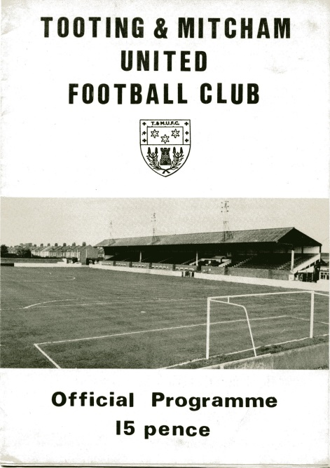
As holders, this had the added benefit of giving us a full exemption again, but despite defeating Tooting & Mitcham and Walton & Hersham, we were robbed on a technicality against Croydon.

Pat O’Connell had left the club, taking much of the team with him and Adrian Hill had limited time to get players in. In addition the Surrey F.A. rules stated that a player had to be registered for 28 days before playing in this tie, so we had all sorts of troubles even fielding a side. Leading striker Steve Hill even played in goal for us, despite having a stress fracture in his shin that prevented him taking an outfield role, and Croydon won 4-0, ending our brief hold on the trophy in criminally farcical circumstances.

In January 1983 Sutton defeated us in the County Cup for the first time ever with a 2-1 win at Gander Green Lane, and the following season the two teams met in the Final, after we had defeated Addlestone & Weybridge (after a replay), Banstead and Croydon, again after a replay. However, we were blown away, losing 4-0.

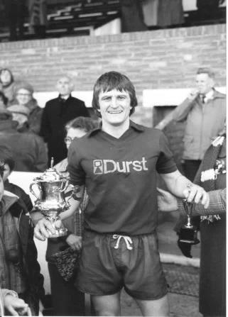
And they did it again the following season with a 4-1 win at West Street after we had held them goalless just two days previously at Sutton. There was a temporary respite in 1985/86 when it was Kingstonian that knocked us out 2-0 at Richmond Road, but it was Sutton again in the Semi-Final of 1986/87 by five clear goals.

We reached the Semi-Final again in 1988/89 but despite holding Carshalton Athletic 2-2 at home, we were harshly defeated 3-0 at Colston Avenue, and three narrow quarter-final defeats in three years followed to Woking, Whyteleafe and Carshalton again.

Since then we have achieved very little in the competition with exception of a Quarter-Final appearance in 2001/02 when we were defeated 3-1 by a Wayne Routledge inspired Crystal Palace, and in 2008/09 when we reached the Semi-Final, aided by an historic and fantastic 3-2 win at Sutton United, plus wins over Redhill and Corinthian Casuals. This gave us the opportunity to visit Step Three side at the time Ashford Town (Middx), but they were too strong for a tired Epsom team and eased through 4-1, despite Robbie Burns equalising to make it interesting for a while.

The competition’s recent reorganisation means that there are no exemptions any more, which makes for a more open draw, and maybe as a result of these potential extra matches, some of the bigger sides have played weaker teams in recent years. This of course does open the way for smaller teams to progress in the competition and recently we have seen Merstham, Ashford Town (Middx) and Godalming Town winning the trophy. Who knows, maybe these days it isn’t as impossible to repeat our 1981 win as you might think!

Left: Our Captain Peter Gaydon lifts the Surrey Senior Cup at Sandy Lane on Easter Monday 1981.

EL Records Premier Challenge Cup
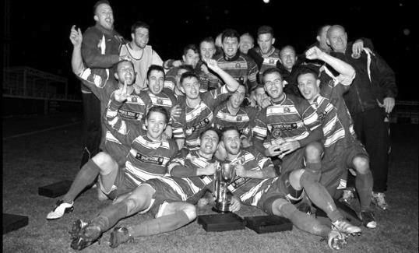
Second Round
Hanworth Villa | 2-4+ | Epsom and Ewell
AFC Hayes | 3-4 | Balham
Epsom Athletic | 1-5 | Windsor
Sutton Common Rovers | 2-1 | Bedfont Sports
Raynes Park Vale | 2-0 | Colliers Wood United
Frimley Green | 1-2 | Banstead Athletic
Westfield | 8-4+ | Redhill
Staines Lammas | 0-1 | Farnham Town
Worcester Park | 8-1 | Cove
Badshot Lea | 0-5 | Guildford City
Chertsey Town | 1-2 | Camberley Town
Cobham | 1-3 | Chessington & Hook United
Hartley Wintney | 4-0 | AC London
Horley Town | 2-2+ 5-4p | Sheerwater
Walton & Hersham | 5-1 | Eversley & California
Ash United | 2-0 | Farleigh Rovers
Third Round
Banstead Athletic | 4-4+ 3-4p | Westfield
Sutton Common Rovers | V | Walton & Hersham
Farnham Town | 0-4 | Camberley Town
Ash United | 0-2 | Windsor
Raynes Park Vale | 2-1 | Hartley Wintney
Guildford City | 2-1 | Balham
Horley Town | 2-0 | Chessington & Hook United
Worcester Park | 3-6 | Epsom & Ewell
Quarter Finals
Windsor | 24/1 | Horley Town
Guildford City | 25/1 | Raynes Park Vale
Westfield | V | Camberley Town
Sutton Common Rovers /  Walton & Hersham | V | Epsom & Ewell

CCL Premier Division Club Directory
ABBEY RANGERS Telephone: 01932-422962 - Ground: Addlestone Moor, Addlestone, Surrey KT15 2QH - Colours: Black & White Stripes/Black/Black

A.F.C. HAYES Telephone: 0208-845-0110 - Ground: Farm Park, Kingshill Avenue, Hayes, Middx. UB4 8DD - Colours: Blue and White Stripes/Blue/Blue

BADSHOT LEA Telephone: 01252-320385 - Ground: Ash United FC, Shawfield Stadium, Youngs Drive, Shawfields Road, Ash, Hampshire. GU12 6RE - Colours: Claret/White/Claret

BEDFONT & FELTHAM Telephone: 0208 890 7264 - Ground: The Orchard, Hatton Road, Bedfont, Middx TW14 9QT - Colours: Yellow & Blue/Blue/Blue

BEDFONT SPORTS Telephone: 0208-831-9067 - Ground: Bedfont Sports Club, Hatton Road, Bedfont, Middx TW14 8JA - Colours: Red & Black Hoops/Black/Red & Black Hoops

CAMBERLEY TOWN Telephone: 01276-65392 - Ground: Krooner Park, Wilton Road, Camberley, Surrey. GU15 2QW - Colours: Red & White Stripes/Blue/Red

CB HOUNSLOW UNITED Telephone: 0208 890 7264 - Ground: The Orchard, Hatton Road, Bedfont, Middx TW14 9QT - Colours: Green/Black/Green

CHERTSEY TOWN Telephone: 01932-561774 - Ground: Alwyns Lane, Chertsey, Surrey. KT16 9DW - Colours: Royal Blue & White Stripes/Royal Blue/Royal Blue

COLLIERS WOOD UNITED Telephone: 0208-942 8062 - Ground: Wibbandune Sports Ground, Robin Hood Way, Wimbledon. SW20 0AA - Colours: Blue & Black Stripes/Black/Black
EPSOM & EWELL Telephone: 01737-553250 - Ground: Chipstead FC, High Road, Chipstead, Surrey. CR5 3SF - Colours: Royal Blue & White Hoops/Royal Blue/Royal Blue

FARNHAM TOWN Telephone: 01252-715305 Ground: Memorial Ground, Babbs Mead, West Street, Farnham, Surrey. GU9 7DY Colours: - Claret & Sky Blue /White/ Claret & Sky Blue

GUILDFORD CITY Telephone: 01483-443322 - Ground: The Spectrum, Parkway, Guildford, Surrey. GU1 1UP - Colours: Red & White Stripes/Black/Black

HANWORTH VILLA Telephone: 0208-831-9391 - Ground: Rectory Meadows, Park Road, off Hounslow Road, Hanworth, Middlesex. TW13 6PN - Colours: Red & White Stripes/Black/Black

HARTLEY WINTNEY Telephone: 01252-843586 - Ground: Memorial Playing Fields, Green Lane, Hartley Wintney, Hants RG27 8DL - Colours: Orange & Black/ Orange /Orange

HORLEY TOWN Telephone: 01293-822000 - Ground: The New Defence, Anderson Way, Court Lodge Road, Horley, Surrey. RH6 8SP - Colours: Claret & Sky Blue/Claret/Claret

KNAPHILL Telephone: 01483-475150 - Ground: Brookwood Country Park, Redding Way, Lower Guildford Road, Knaphill, Surrey. GU21 2AY - Colours: Red/Black/Red

NORTH GREENFORD UNITED Telephone: 0208 422 8923 - Ground: Berkeley Fields, Berkeley Avenue, Greenford, Middx UB6 0NX - Colours: Royal Blue & White/Royal Blue/Royal Blue

SUTTON COMMON ROVERS Telephone: 01932-866386 - Ground: Sutton United FC, Gander Green Lane, Sutton, Surrey SM1 2EY - Colours: Yellow/Black/Black

RAYNES PARK VALE Telephone: 020-8540-8843 - Ground: Prince Georges Playing Field, Grand Drive, Raynes Park, London. SW20 9NB - Colours: Blue/Blue/Red

SPELTHORNE SPORTS Telephone: 01932-961055 - Ground: Spelthorne Sports Club, Staines Road, Ashford Common, Ashford, Middx. TW15 1RY - Colours: Light & Dark Blue/Dark Blue/Light Blue

WALTON & HERSHAM Telephone: 01932 245263 - Ground: Stompond Lane, Walton on Thames, Surrey KT12 1HF - Colours: Red/Red/Red

WESTFIELD Telephone: 01483-771106 - Ground: Woking Park, Kingfield Road, Woking, Surrey. GU22 9BA - Colours: Yellow/Black/Black

WINDSOR Telephone: 01753-860656 - Ground: Stag Meadow, St Leonards Road, Windsor, Berks SL4 3DR - Colours: Red/Red/Red

Every Opponent A-Z
Over the years we have played many, many different opponents. Exactly how many is a difficult question, as it all depends on your definition. Are Camberley & Yorktown different to Camberley Town, or are Epsom Town different to Epsom F.C. or Epsom & Ewell F.C.?

In my analysis I have classed both of the above examples as the same team, and will work through them all from A to Z. Some we have played many times, whilst others we have met just once or twice. Enjoy!

Tonbridge: Played 1 - W1 D0 L0 - F3 A1 - PPG - 3.00 - Perfect

We have only met Tonbridge on one competitive occasion when we were drawn together in the Second Qualifying Round of the F.A. Trophy at West Street on 28th November 1981. It was scoreless at the half before we went behind but recovered to score three times in the final twenty minutes from Dave Dyer, Steve Hill and a Tommy Tuite penalty. This earned us a crack at Alliance Premier League Gravesend & Northfleet who we defeated after two replays before then beating Cheltenham Town on their own patch and being narrowly defeated at home by eventual finalists Altrincham, so it’s fair to say it was quite an important recovery!

Tonbridge currently play at Step Three in the Ryman League Premier Division, having spent a few years in the Conference South until 2016 when they were relegated.

Tooting Town: Played 17 - W10 D1 L6 - F39 A26 - PPG - 1.82 - Good

Now you could argue here that Tooting Town should be included with Tooting & Mitcham United. The two clubs were one and the same, and both played at Sandy Lane before merging with Mitcham Wanderers in 1932. However, I have already covered Mitcham separately and so putting Tooting in with the newer club just looked wrong. It also required more space than the two pages I had, so look forward to seeing the merged club in the next home programme!

Toting Town were originally formed back in the 1880s and played at a couple of grounds on Figgs Marsh and a venue called Lonesome before settling on Sandy Lane. They were members of the London League when we joined in 1927 and League matches commenced at that point. However, we had met once already by then, on 18th September 1926 in an F.A. Cup Preliminary Round tie where they edged us out by the odd goal in seven. We did actually play them once as an Intermediate club, losing 2-0 on 23rd April 1924 in the Quarter Final of the South London Charity Cup. We were meant to be playing a Reserve side but they put their first team in, so under the circumstances it was quite a decent performance!

We never really had the same rivalry with Tooting as we did with Mitcham. This is probably because we played them in less interesting competitions or in very early rounds. However, we commenced our league meetings in our title winning season of 1927/28, winning both matches, 2-0 at Sandy Lane on our first visit there as a Senior club on 7th January 1928 and a 2-1 win at West Street on 25th February in front of 1,500 spectators.

In the 1928/29 season we again won both League matches but again were defeated in the F.A. Cup encounter by two goals to one at Sandy Lane. In 1929/30 we met on five occasions, due to the Wilson Hospital Cup, which we had decided to enter. The original match was drawn 1-1 on a Wednesday afternoon at West Street and so a replay was required, which would not take place until a Thursday evening in April, when we won 3-0. This left us with a final against Mitcham Wanderers that would be played the following season and would be one of the reasons we played them seven times in 1930/31!

The other three matches all went the way of the Terrors who knocked us out of the Surrey Senior Cup in 1930 just as we were hoping to repeat our run to the Final from the previous season.

Although we would meet Mitcham many times in the following season there was still time to play Tooting first and a 4-1 win would give us our only serious competitive competition win against them as our F.A. Cup campaign lasted for a further round. The League matches both came in April and resulted in a home win for each team.

For season 1931/32 we had been determined as Tooting’s Easter opponents and we met on Good Friday and Easter Monday, winning both comfortably, 5-1 away and 5-2 at home with Billy Williams scoring seven of our ten goals!

However, by that stage of the season it was already known that the two clubs would be merging for the 1932/33 season so it’s hard to say whether their team played with the same intensity in those matches, while we were chasing the runners up spot for the first of what would become five times over the next eight seasons, so maybe we’d have won anyway!

And there we’ll leave it for now, picking up next week in 1932.

Here is a very unusual photo that you almost certainly will not have seen,
showing Sandy Lane in 1930 with its original grandstand in place.
This stand would be replaced in the late forties with the one we would all remember.
Courtesy Jeff Brooks – Author of Tooting on the Move

Tottenham Hotspur XI: Played 3 - W2 D0 L1 - F8 A8 - PPG - 2.00 - Very Good

Now it’s quite obvious that we didn’t play a first team, but back in the thirties our Club President was Arthur Turner who was the long serving Secretary and future wartime Manager at White Hart Lane. I have no idea how the arrangement came about, but it was clear that they saw us as a potential nursery side, as was the case over in Kent with Northfleet before they merged after World War Two with Gravesend United. He would occasionally send teams over for high profile matches that would attract decent gates and we won the first two in April and October of 1936 by 3-2 and 2-1 before a separate visitation occurred in October 1946 when they won 5-3.

It should also be mentioned that in earlier years we played twice against an official Tottenham Reserves team, where things were a bit more difficult:

Tottenham Hotspur Reserves: Played 2 - W0 D0 L2 - F3 A13 - PPG - 0.00

On 1st December 1928 we were battered 7-0 at West Street with a 6-3 defeat following on 30th March 1929.

Player Sponsorship
Here is the current list for the 2016/17 season showing all of our players and Management that are available for sponsorship.

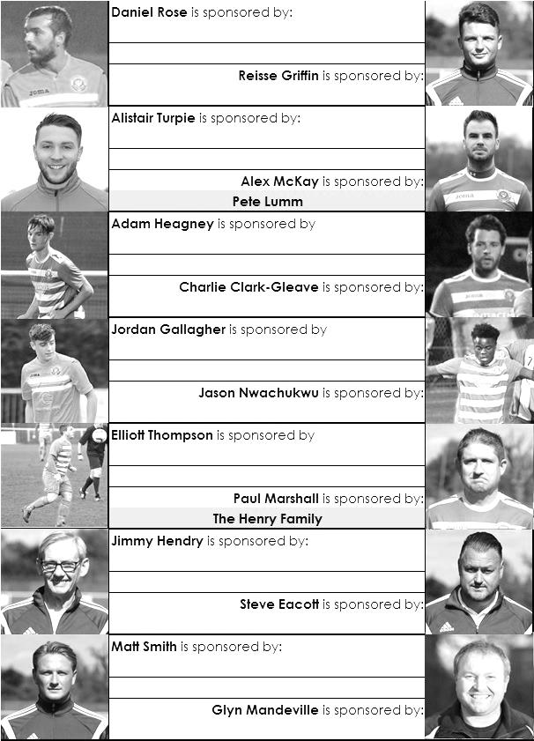

Sponsorship costs just £40 and it is easy to do. Just select a player who has not been previously sponsored and let a Committee Member know that you would like to sponsor them. Beware though. Until we have received the money it is possible for someone to jump in front of you, so don’t delay, sponsor today!
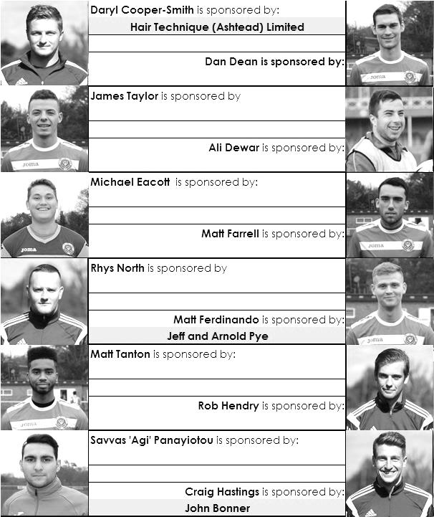

Match and Ball Sponsorships – 2016/17
Opponent | Date | Match Sponsor | Ball Sponsor
Gravesham Borough | 07/08/16 | Club President - Stella Lamont
Gravesham Borough | 07/08/16 | Relocation Committee Member - Mike Lovett
CB Hounslow United | 16/08/16 | EEFC Management Committee
Abbey Rangers | 23/08/16 | Steve & Geoff Dyke
Horley Town (11.30am) | 29/08/16 | In Memory of Chris Henry
Abbey Rangers (LC) | 06/09/16 | Paul Merritt
Camberley Town | 10/09/16 | Building Shop Ltd
Knaphill | 24/09/16 | EEFC Holding Company Director – Pete Lumm
Bridon Ropes (FAV) | 22/10/16 | George and Joseph Saunders
Sutton Common Rovers | 08/11/15 | Alex McKay Senior
Abbey Rangers (FAV) | 13/11/16 | EEFC Holding Company Director – Dave Ellins
Windsor | 15/11/16 | In Memory of Wally Dyke
Bedfont Sports | 19/11/16 | John Bonner
AFC Hayes | 26/11/16 | Jack Jarman
Chipstead (SSC / DWT) | 06/12/16 | Trevor Stotten
Hanworth Villa | 13/12/16
Chertsey Town | 17/12/16
Raynes Park Vale (11.30am) | 27/12/16
Spelthorne Sports | 07/01/17
Guildford City | 17/01/17
Bedfont & Feltham | 21/01/17 | Programme Editor - Richard Lambert
Badshot Lea | 04/02/17
Westfield | 18/02/17
Walton & Hersham | 04/03/17
Hartley Wintney | 18/03/17
Farnham Town | 25/03/17
Colliers Wood United (1pm) | 14/04/17 | Good Friday match – make a note!
North Greenford United | 22/04/17 | Club President - Stella Lamont
For League, League Cup and Surrey Senior Cup Matches:
Match sponsorship - £40.00 Match ball sponsorship - £25.00. Combined £55.00.
For F.A. Cup and F.A. Vase matches:
Match sponsorship - £50.00 Match ball sponsorship - £30.00. Combined £65.00.

Sponsorship includes: (x2 for match, x3 for match and ball)

Admission, programmes, hospitality and advertising and mascot for the day (if required).
If you are interested, just speak to a Committee Member, or drop me an email at: richard.c.lambert@gmail.com

We also thank our Kit Sponsors INTERCEM

Salts Super Six Predictor
The Salts Super Six Predictor is live again for today’s match and the tickets are on sale at today’s game to the left of the gate.

The jackpot has grown steadily and we can advise that our record figure continues to grow and is now £490. Please note that these matches will be played on Saturday 10th December.

The competition is easy to play! To win, you simply need to predict the results of six matches correctly from the three options, fill in the form and make sure it is back with our seller before the deadline on the ticket. The latest fixtures are shown below.

If you are a club regular, you just need to place your name on the sheet, although if you aren’t, then we’ll need a contact number from you too. We will announce any winners on the website within three working days, so don’t worry, we won’t miss you!

Please note that if there is more than one winner, the prize pot would be shared between the winners. All you need to do now is have a go, as many times as you like!

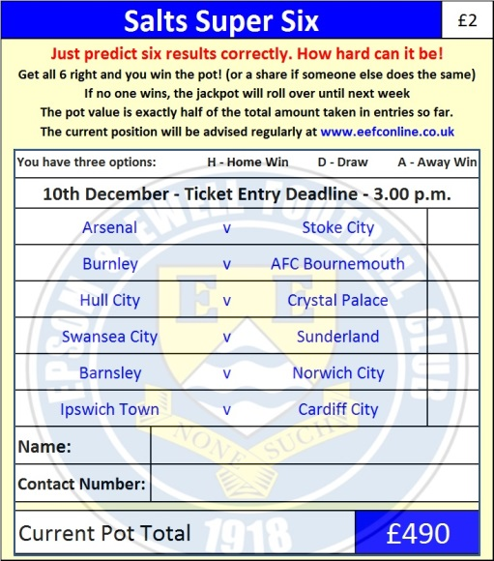

Good luck!

Surrey Senior Cup 2 – Dave Wilson Trophy X
Tuesday, 6th December 2016 - Kick-off 7.45 p.m.

Epsom and Ewell  (Royal Blue & White hoops) | V |  | Chipstead  (Green and White)
Squad | NUMBERS |  | Squad
Michael Eacott |  |  | Luke Colquhoun
James Taylor |  |  | Tommy Smith
Matt Tanton |  |  | Chris O’Flaherty
Craig Hastings |  |  | Vernon Francis
© Dan Dean |  |  | Dan Aldous
Alex McKay |  |  | Callum Maclean ©
Jordan Gallagher |  |  | Rob Hastings
Matt Farrell |  |  | Dan Cumber
Daryl Cooper-Smith |  |  | Raheem Sterling-Parker
Savvas ‘Agi’ Panayiotou |  |  | Karl Parker
Matt Ferdinando |  |  | Scott Simpson
Jason Nwachukwu |  |  | Mario Quiasacca
Reisse Griffin |  |  | Steve Betancourt
Rob Hendry |  |  | Jason Henry
Adam Heagney |  |  | Jack Higgins
Daniel Rose |  |  | Tony Stone
Alistair Turpie
Charlie Clark-Gleave
Matt Smith
Glyn Mandeville | MANAGER |  | Antony Williams
Matt Smith | ASSISTANT |  | Callum Maclean /  Gareth Graham
Steve Eacott / Alex McKay / Jimmy Hendry | COACHES / PHYSIO |  | Robert Kember / Tony Stone / Malcolm Cooper
REFEREE: T.Greaves
ASSISTANTS: M.Coen, D.Hayes
Today’s Match and Match Ball are kindly sponsored by
Chipstead F.C. Social Media Officer Trevor Stotten

OUR NEXT VISITORS TO HIGH ROAD
Hanworth Villa
Combined Counties League – Premier Division
Tuesday 13th December 2016 – 7.45 p.m.

